## ACTIVITY 1: LEED (LEADERSHIP IN ENERGY & ENVIRONMENTAL DESIGN) Certification

Activity Objective: Identify a LEED prerequisite for at least two of the LEED seven categories and then develop the credit to the prerequisite for exceeding that prerequisite.

REVIEW VIDEOS:

How to get LEED certified Rating: <https://www.youtube.com/watch?v=cWZ3JjPZNf0>

How using LEED standards will lower our carbon footprint <https://www.youtube.com/watch?v=N8bQ67XBXt8>

LEED Credits for Energy Modelers: <https://www.youtube.com/watch?v=-fMQMgUURMI>

Definition: LEED (LEADERSHIP IN ENERGY & ENVIRONMENTAL DESIGN) is a worldwide green building certification program developed by the USGBC or U.S. Green Building Council. USGBC developed LEED to include a set of rating systems for the design, construction, operation, and maintenance of green buildings, homes, and neighborhoods. USGBC offers a group of LEED professional credentials that denote expertise in the field of green building. USGBC incentivizes LEED certification by awarding extra certification points to building projects completed with a LEED-certified professional on staff. This design concept intends to help building owners and operators be environmentally responsible and use all resources efficiently. LEED grew from a single building standard for new construction to an all-inclusive system of interrelated standards that cover all phases from design and building to the maintenance and operation of buildings.

LEED 2009 incorporates 10 rating systems for the design, construction and operation of buildings, homes and neighborhoods. One of the 5 predominant categories is under the LEED professional construction program is Green Building Design & Construction and sub-category LEED for New Construction (LEED-NC).

The LEED rating system is used to evaluate the environmental performance of a building and boost conversion towards a sustainable design. The system is credit-based, allowing projects to earn points for environmentally friendly actions taken during construction and use of a building. The program is not rigidly structured; not every project must meet identical requirements to qualify.

Buildings can qualify for 4 different LEED certification levels:

• Certified: 40–49 points

• Silver: 50–59 points

• Gold: 60–79 points

• Platinum: 80 points and above

A building must comply with environmental laws and regulations, occupancy scenarios, building permanence and pre-rating completion, site boundaries and area-to-site ratios. Its owner must share data on the building's energy and water use for five years after occupancy (for new construction) or date of certification (for existing buildings). Each of the performance categories also have mandatory measures in each category, which receive no points.

1. **The 7 LEED categories**:
   1. Sustainable Sites
   2. Water Efficiency
   3. Energy and Atmosphere
   4. Materials and Resources
   5. Indoor Environmental Quality
   6. Innovation in Design
   7. Regional Priority

There are 100 possible base points distributed across 7 credit categories: Sustainable Sites, Water Efficiency, Energy and Atmosphere, Materials and Resources, Indoor Environmental Quality, Innovation in Design, and Regional Priority. Ten additional points may be earned: four additional points may be received for Regional Priority Credits, and six additional points for Innovation in Design (which includes high performance credits for existing credit categories). Each of the 7 credit categories contain **PREREQUISITES**; characteristics that are required. The prerequisites do not have points assigned to them because they are compulsory or mandatory for certification.

While projects can pick and choose the credits they want to pursue, prerequisites are required. They set the minimum requirements that all buildings need to meet in order to achieve LEED certification. Completing the requirements of prerequisites will not earn points. They are the foundation of a building project. **Credits** are what sets your building apart. Credits allow project teams to customize how they pursue certification. By fulfilling credits, projects earn points that determine its certification level: Certified (40-49 points), Silver (50-59 points), Gold (60-79 points) and Platinum (80+). You can go for any credit you want within your chosen rating system as long as it applies to your project type. Certain credits pair well with certain prerequisites or even other credits. The more **points** the higher the reward. When it comes to LEED there are many rewards ranging from healthier spaces to buildings that save money and resources. The number of points a project earns determines the level of LEED certification it receives.

Materials: Chapter 11, paper, computer, printer. Internet Access

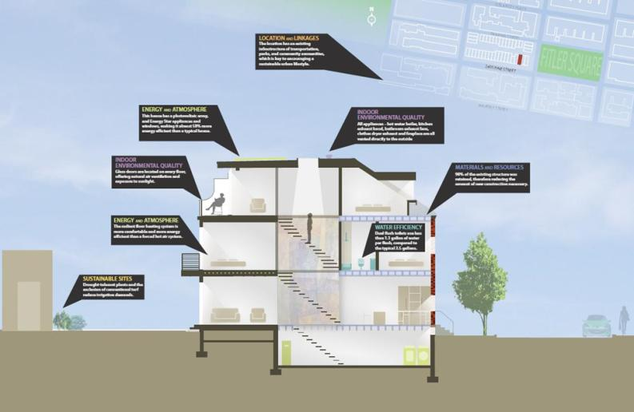

### Procedure:

1. Work as partners or small teams.
2. Review the text in chapter 11 on LEED certification and research the topic on the Internet as to the prerequisite requirements.
3. **The 7 LEED categories**:
   1. Sustainable Sites
   2. Water Efficiency
   3. Energy and Atmosphere
   4. Materials and Resources
   5. Indoor Environmental Quality
   6. Innovation in Design
   7. Regional Priority
4. Identify a prerequisite for at least two of the above 7 categories and then write up the credit to the prerequisite for exceeding that prerequisite. The prerequisite is mandated by LEED and then the intent is written by you or your team to obtain that credit or what amount of credit under what situations. Detail the situations to achieve credit beyond the prerequisite in a report. **For example**, **#2 Water Efficiency** has a prerequisite of a 20% reduction in water use over conventional construction. Your suggested activity would receive additional points if you achieve greater water use reduction than 20%. However, it must achieve 20% at the minimum to meet the prerequisite or it will not be considered for certification. You would need to detail what you would do in your design to exceed the 20% reduction.
5. **Prepare a power point presentation on your plans**

|  |  |  |  |  |  |  |  |  |  |
| --- | --- | --- | --- | --- | --- | --- | --- | --- | --- |
| RUBRIC | | **4**  **World-Class Learner** | **3**  **Proficient  Learner** | **2**  **Developing Learner** | **1**  **Emergent Learner** | | --- | --- | --- | --- | | **Learner at this level has gone beyond mastery of knowledge, skills, & attitudes described in project. World-class learner consistently exhibits high-quality performance.** | **Learner at this level has had opportunities to apply knowledge, skills, & attitudes of component of project. Proficient learner has mastered essential attributes, thus proving mastery.** | **Learner at this level has been exposed to & had opportunity to apply knowledge, skills, & attitudes of project. Developing learner may have only a few essential attributes to master before mastery.** | **Learner at this level may or may not have been exposed to knowledge, skills, & attitudes required by academic standards of the project.** | |
|  | **1= Emergent Learner**  **2 = Developing Learner**  **3 = Proficient Learner**  **4 = World-Class Learner** |