## ACTIVITY 2: Sustainable Lighting Benefits

Activity Objective: Construct a low voltage lighting circuit to demonstrate the lower electricity usage of LED lighting as opposed to incandescent lights

REVIEW VIDEO: Sustainability and LED Lighting (Ted Talk) Rating: <https://www.youtube.com/watch?v=JnK1DpcXTTU>

Definition: LED (Light Emitting Diode) Lights (Figure 14): A light-emitting diode (LED) is a two-lead semiconductor light source. It is a PN junction diode that emits light when triggered. When a suitable voltage is applied to the leads, electrons recombine with electron holes within the solid-state device releasing energy in the form of photons. This effect is called electroluminescence, and the color of the light is determined by the energy band gap of the semiconductor.

LED lighting is different than incandescent and fluorescent lighting in several ways. LED lighting uses light emitting diodes to produce light very efficiently. Electrical current passes through semiconductor material, which illuminates the LED and the heat produced is absorbed into a heat sink

Common LED colors include amber, red, green, and blue. There is actually no “white” LED. To get white light, for lighting a building, different color LEDs are mixed or covered with a phosphor material that converts the color of the light. The phosphor is the yellow material you can see on some LED products. LEDs are now being incorporated into bulbs and fixtures for general lighting applications. Some LED bulb solutions may look like familiar light bulbs and some may not, but can better match the performance of traditional light bulbs. Some LED light fixtures may have LEDs built–in as a permanent light source.

The activity you are about to perform will demonstrate that LED lighting uses less electricity in terms of current or amperes drawn. Using less current is using less electricity.

When electrons move from one atom to another in this way, this process is called electron drift. If an electromotive force is present, the moving electrons will always move in one direction away from the electromotive force. This organized movement of electric charge in one direction is called **current**. The flow of electrons through a conductor is called current. Current is measured in amperes or amps (A). Current is powerful.

In order to move water through the plumbing in your house and to the kitchen sink, water pressure is required. We can re-word this statement in electrical terms: “In order to move electrons through the wiring in your house and to the kitchen light, electrical pressure is required.” This electrical pressure is called **voltage**. Technically, it’s called electrical potential, but it will help you to understand it if you think of it as electrical pressure. Voltage is measured in volts. Power or electrical usage is measured in Watts and Power = current x voltage.

Materials:

* Chapter 11, paper, computer, printer, Internet Access,
* 12 volt incandescent bulbs
* LED light bulbs purchased from Radio shack
* 9-VOLT battery
* DMM (Digital Multimeter) purchased for Chapter 5 activity 2,
* Jumper wires also used for Chapter 5 activity 2: RADIOSHACK #2781157 $7.49

Procedure

1. Work as a team in pairs, or alone for this activity.

#### **LED AMPERAGE:**

1. Take the DMM (Digital Multimeter) using for Activity 2 from Chapter 5 and hook up the leads as shown in Figure 1

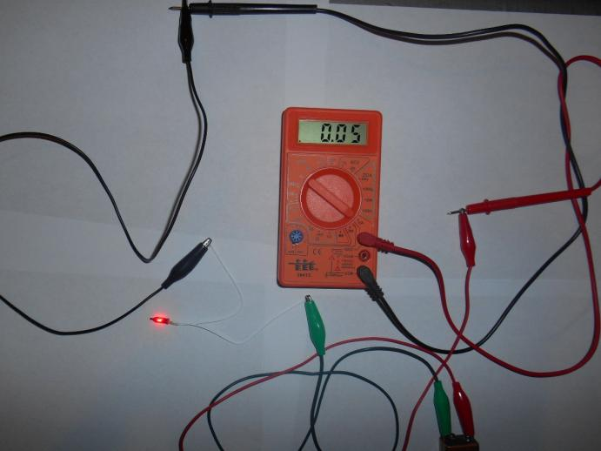

Figure 1 Connecting the DMM in a series circuit from a 9-volt battery to an LED

1. Plug the BLACK lead into the common or COM port
2. Plug the RED lead into the 10 ADC port (10 amps DC)
3. Connect a jumper wire from the RED lead probe to the positive terminal of the 9-volt battery
4. Connect a jumper wire from the BLACK lead probe to one terminal of a LED (Light Emitting Diode) purchased from Radio Shack.
5. Connect another jumper wire from the other LED terminal and connect I to t he 9-volt battery ground.
6. Turn the Rotary Dial of the DMM to 10A and observe and record the amperage_________
7. In Figure 1, the author measured 0.050 amps or 50 milliamps
8. Power = Current (0.050 amps) x voltage 9 volts = 0.450 watts
9. What wattage did you get? _________________________
10. Turn OFF the DMM

#### **INCANDESCENT BULB AMPERAGE**

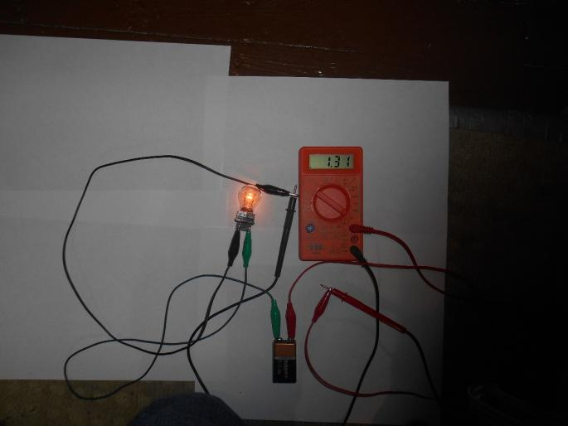

Figure 2

1. With the DMM still in the off position, YOU CAN KEEP ALL OF THE SAME CONNECTIONS as in the LED experiment.
2. Remove the LED and substitute a 3057 automotive taillight bulb purchased from Walmart or any automotive parts store like AutoZone.
3. Turn the Rotary Dial of DMM to 10A and observe and record the amperage**_______________.**
4. In Figure 1, the author measured 1.31 amps or 1,310 milliamps.
5. Power = Current (1.31 amps) x voltage 9 volts = **11.79 watts**
6. What wattage did you get? _________________________
7. You must take your reading quickly because at a 1 amp draw, the battery will discharge quickly
8. Turn OFF the DMM
9. Disconnect all wiring

|  |  |  |  |  |  |  |  |  |  |
| --- | --- | --- | --- | --- | --- | --- | --- | --- | --- |
| RUBRIC | | **4**  **World-Class Learner** | **3**  **Proficient  Learner** | **2**  **Developing Learner** | **1**  **Emergent Learner** | | --- | --- | --- | --- | | **Learner at this level has gone beyond mastery of knowledge, skills, & attitudes described in project. World-class learner consistently exhibits high-quality performance.** | **Learner at this level has had opportunities to apply knowledge, skills, & attitudes of component of project. Proficient learner has mastered essential attributes, thus proving mastery.** | **Learner at this level has been exposed to & had opportunity to apply knowledge, skills, & attitudes of project. Developing learner may have only a few essential attributes to master before mastery.** | **Learner at this level may or may not have been exposed to knowledge, skills, & attitudes required by academic standards of the project.** | |
|  | **1= Emergent Learner**  **2 = Developing Learner**  **3 = Proficient Learner**  **4 = World-Class Learner** |