## ACTIVITY 3: Sustainability and Lighting

Activity Objective: Design a light shelf that is used to reflect daylight to the ceiling and decrease daylight levels adjacent to a window and provide more daylight light to conserve the use of electric lighting.

Materials: Chapter 11, paper, computer, printer, Internet Access, drawing program

Definition: Daylighting is an important element of sustainable design. The incorporation of daylight in the design of a building is justified for a number of reasons. Besides energy savings, daylighting provides a host of non-energetic benefits and reduces dependence on fossil fuels. Research regarding daylight has shown strong numerical correlations with daylighting and increases in productivity. Light transmission by the human eye regulates melatonin production in the pineal gland, which regulates sleep. Building energy consumption can be reduced if daylight is used in appropriate quantities to light interior spaces and reduce the dependence on electric lighting.

Skylights are common daylight delivery system that can be built into the roof. Yet, they can only be used at the top floor of a building or in a single story building. However, you can use an atrium to permit daylight from skylights to be introduced to multiple floors.

Windows are the most common daylight delivery device and provide considerable daylight. A window offers a distinct advantage because it provides the occupants with a view of the exterior, which is healthier and more esthetic for those who have to work inside all day. With no obstructions and a standard window with blinds, usable daylight can only penetrate into a space approximately 1-2 times the height of the top of the window above the work area.

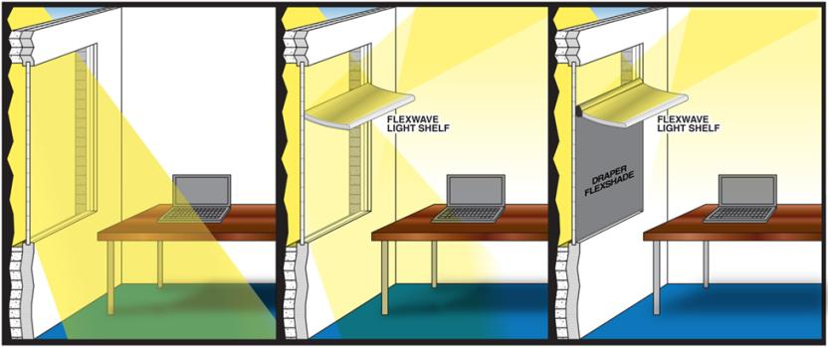

A light shelf shown above is a daylight delivery system that is used to reflect daylight to the ceiling and decrease daylight levels adjacent to a window.

Sustainable lighting design concerns can help guide overall building performance considerations. The following lighting systems are available to save and sustain energy”

Procedure:

1. Work as partners or small teams.
2. Using either a CAD based drawing program or a hand drawn diagram on graft paper of a light shelf that is used to reflect daylight to the ceiling and decrease daylight levels adjacent to a window and provide more daylight light to conserve the use of electric lighting.
3. Develop a Power point presentation showing the difference in light with and without the light shelf.

|  |  |  |  |  |  |  |  |  |  |
| --- | --- | --- | --- | --- | --- | --- | --- | --- | --- |
| RUBRIC | | **4**  **World-Class Learner** | **3**  **Proficient  Learner** | **2**  **Developing Learner** | **1**  **Emergent Learner** | | --- | --- | --- | --- | | **Learner at this level has gone beyond mastery of knowledge, skills, & attitudes described in project. World-class learner consistently exhibits high-quality performance.** | **Learner at this level has had opportunities to apply knowledge, skills, & attitudes of component of project. Proficient learner has mastered essential attributes, thus proving mastery.** | **Learner at this level has been exposed to & had opportunity to apply knowledge, skills, & attitudes of project. Developing learner may have only a few essential attributes to master before mastery.** | **Learner at this level may or may not have been exposed to knowledge, skills, & attitudes required by academic standards of the project.** | |
|  | **1= Emergent Learner**  **2 = Developing Learner**  **3 = Proficient Learner**  **4 = World-Class Learner** |