## ACTIVITY 1: How the Internet Has Improved Sustainability in My Life

Activity Objective: Write an essay or group report with a Power Point presentation on how the Internet is used in your life or the lives of your team toward sustainability.

Definition: The following Internet milestones move toward what we see today as the Internet:

* 1971 was the start of the use of the non-ruggedized Honeywell 316 as an IMP. It could also be configured as a Terminal Interface Processor (TIP), which provided terminal server support for up to 63 ASCII (American Society for Computer Science Information Interface) serial terminals through a multi-line controller in place of one of the hosts. The 316 was configured with 40 kB of core memory for a TIP.
* In 1975, BBN introduced IMP software running on the Pluribus multi-processor. These appeared in a few sites.
* In 1981, BBN introduced IMP software running on its own C/30 processor product.
* In 1983, TCP/IP (Transmission Control Protocol/Internet Protocol) was one of the main protocols of the Internet protocol suite protocols replaced NCP as the ARPANET's principal protocol, and the ARPANET then became one subnet of the early Internet.
* The original IMPs and TIPs were phased out as the ARPANET was shut down after the introduction of the NSFNet, but some IMPs remained in service as late as July 1990.
* The ARPANET Completion Report, jointly published by BBN and ARPA, concludes that the ARPANET program has had a strong and direct feedback into the support and strength of computer science, from which the Internet came from.
* ARPANET was decommissioned in 1990
* Senator Al Gore began work on the 1971 saw the start of the use of the non-ruggedized (and therefore significantly lighter) Honeywell 316 as an IMP. It could also be configured as a Terminal Interface Processor (TIP), which provided terminal server support for up to 63 ASCII serial terminals through a multi-line controller in place of one of the hosts.[39] The 316 featured a greater degree of integration than the 516, which made it less expensive and easier to maintain. The 316 was configured with 40 kB of core memory for a TIP. The size of core memory was later increased, to 32 kB for the IMPs, and 56 kB for TIPs, in 1973.

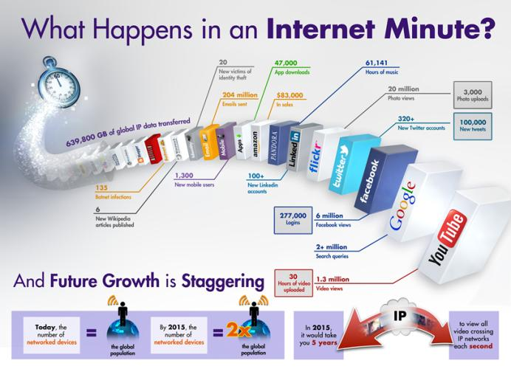

What happens in an Internet Minute

The above Figure shows what can happen in an Internet minute. In 1991, US Senator Al Gore began work on the High Performance Computing Act of 1991 (HPCA) that led to the development of the National Information Infrastructure and the funding of the National Research and Education Network (NREN). NREN proposed to build communications networks, interactive services, interoperable computer hardware and software, computers, databases, and consumer electronics in order to put vast amounts of information available to both public and private sectors. It would have contained Internet devices such as: cameras, scanners, keyboards, telephones, fax machines, computers, switches, compact disks, video and audio tape, cable, wire, satellites, optical fiber transmission lines, microwave nets, switches, televisions, monitors, and printers used to transmit, store, process, and display voice, data, and images. NREN would also embraced a wide range of interactive functions, user-tailored services, and multimedia databases that were interconnected in a technology-neutral manner without favoritism to any one industry.

REVIEW VIDEOS:

History of the Internet: <https://www.youtube.com/watch?v=h8K49dD52WA>

What is the IoT?: <https://www.youtube.com/watch?v=S64s3GrZlSM>

Materials: Chapter 13, paper, computer, printer, Internet Access, MS Power Point

### Procedure:

1. Work as partners or small teams.
2. Research and brainstorm how the Internet has changed your life and the lives of your team members. How do you use it and what has it done or can it do toward sustainability
3. Based on the text in chapter 13 and an Internet search write an essay or group report on how the Internet is used in your life or the lives of your team toward sustainability.
4. Create a Power Point presentation on your essay or report

|  |  |  |  |  |  |  |  |  |  |
| --- | --- | --- | --- | --- | --- | --- | --- | --- | --- |
| RUBRIC | | **4**  **World-Class Learner** | **3**  **Proficient  Learner** | **2**  **Developing Learner** | **1**  **Emergent Learner** | | --- | --- | --- | --- | | **Learner at this level has gone beyond mastery of knowledge, skills, & attitudes described in project. World-class learner consistently exhibits high-quality performance.** | **Learner at this level has had opportunities to apply knowledge, skills, & attitudes of component of project. Proficient learner has mastered essential attributes, thus proving mastery.** | **Learner at this level has been exposed to & had opportunity to apply knowledge, skills, & attitudes of project. Developing learner may have only a few essential attributes to master before mastery.** | **Learner at this level may or may not have been exposed to knowledge, skills, & attitudes required by academic standards of the project.** | |
|  | **1= Emergent Learner**  **2 = Developing Learner**  **3 = Proficient Learner**  **4 = World-Class Learner** |