## ACTIVITY 4: Smart Lighting

Activity Objective: Reduce the wattage of the lighting in your home, office, through smart lighting systems by designing an actual system and by calculating the current wattage of your lighting and the what reduced wattage will be with smart lighting.

Materials: Chapter 13, paper, computer, printer, Internet Access, smart bulbs

Definition: Light switches are the next system to become part of home automation, which we can call smart lighting (Figure). Smart bulbs can be controlled directly from your smartphone. As helpful as these bulbs may be, a single bulb can cost hundreds of dollars. Smart lighting switches offer the same functionality without having to replace all the bulbs or light fixtures in the house. The lighting system in your home is used to control the lights. A smart switch or system can be designed with a solenoid controlled ON/OFF switch so you can immediately turn the light or system off or on from anywhere. The most important feature is you operate this smart light switch or system with your smart device.

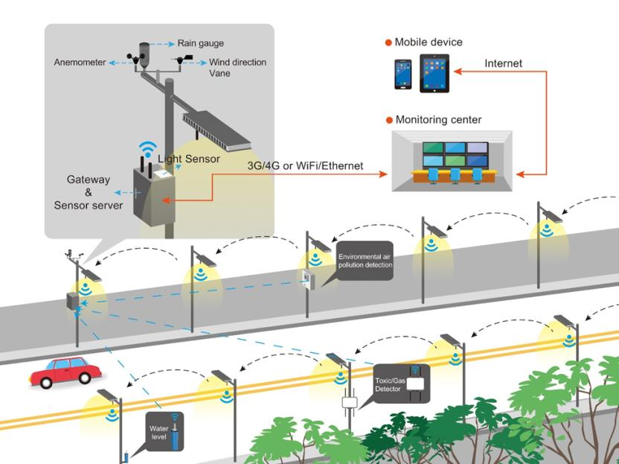

REVIEW VIDEOS:

How smart lighting devices can help sustainability; IoT Smart Lighting talk Rating: <https://www.youtube.com/watch?v=H23Lq8y4A9Y>

### Procedure:

1. Work as partners or small teams.
2. Research and brainstorm smart lighting in the home, office, or school toward improving sustainability.
3. Calculate the current wattage of the lighting in a location, to include methods of tuning the lights off during periods of non-usage.
4. Determine what smart lighting systems could be used to improve the sustainability of your project.
5. Develop charts and graphs to support your conclusions.

|  |  |  |  |  |  |  |  |  |  |
| --- | --- | --- | --- | --- | --- | --- | --- | --- | --- |
| RUBRIC | | **4**  **World-Class Learner** | **3**  **Proficient  Learner** | **2**  **Developing Learner** | **1**  **Emergent Learner** | | --- | --- | --- | --- | | **Learner at this level has gone beyond mastery of knowledge, skills, & attitudes described in project. World-class learner consistently exhibits high-quality performance.** | **Learner at this level has had opportunities to apply knowledge, skills, & attitudes of component of project. Proficient learner has mastered essential attributes, thus proving mastery.** | **Learner at this level has been exposed to & had opportunity to apply knowledge, skills, & attitudes of project. Developing learner may have only a few essential attributes to master before mastery.** | **Learner at this level may or may not have been exposed to knowledge, skills, & attitudes required by academic standards of the project.** | |
|  | **1= Emergent Learner**  **2 = Developing Learner**  **3 = Proficient Learner**  **4 = World-Class Learner** |