**ACTIVITY 4: What Can You Do to Get to Zero Waste?**

Activity Objective: Locate in your personal life and the lives of your team what areas you can reduce your waste to near zero and catalog the items you are reducing to reuse, recycle or regulate.

Materials: Chapter 16, paper, computer, printer, Internet Access. Material being reduced

Definition: Zero Waste Strategy is a thinking that encourages the redesign of resource life cycles so that all products are reused. No trash is sent to landfills or incinerators and the process is done in a way that resources are reused in nature. The definition adopted by the Zero Waste International Alliance (ZWIA) is designed as follow:

1. Zero Waste is an ethical, economical, efficient and visionary goal used to guide people in changing their lifestyles and practices to emulate sustainable natural cycles, where all discarded materials are designed to become resources for others to use.
2. Zero Waste means designing and managing products and processes to systematically avoid and eliminate volume and toxicity of waste and materials, conserve and recover all resources, and not burn or bury them.
3. Implementing Zero Waste eliminates all discharges to land, water or air that are a threat to planetary, human, animal or plant health

Zero Waste refers to waste management and planning approaches which emphasize waste prevention as opposed to end-of-pipe waste management. It is a whole systems approach that aims for a massive change in the way materials flow through society, which results in no waste. Zero waste encompasses more than eliminating waste through recycling and reuse, it focuses on restructuring production and distribution systems to reduce waste. Zero waste is a goal and not really a hard target. Zero Waste provides guiding principles for continually working towards eliminating wastes.

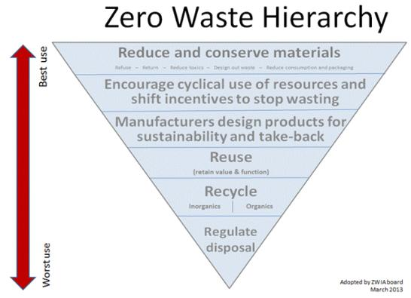

Zero Waste Hierarchy 3Rs (Reduce, Reuse, Recycle, Disposal); describes a development of policies and a strategy to support the Zero Waste system, from highest and lowest use of materials

The Zero Waste Hierarchy (above Figure) describes a development of policies and a strategy to support the Zero Waste system, from highest and lowest use of materials. It is designed to be applicable to all groups, from policy-makers to industry and individuals. It intends to provide more depth to the recognized 3Rs (Reduce, Reuse, Recycle); to encourage policy, activity and investment at the top of the hierarchy; and to provide a guide to develop systems or products that move us closer to Zero Waste.

The most effective way to reduce waste is to not generate it in the first place. Making a new product requires materials and energy. Raw materials must be extracted from the earth, and the product must be fabricated then transported to the consumer. As a result, reduction and reuse are the most effective ways you can save natural resources, protect the environment and save money.

To reuse something is to use it again after it has been used. This includes conventional reuse where the item is used again for the same function and creative reuse where it is used for a different function. In contrast, recycling is the breaking down of the used item into raw materials which are used to make new items. Reuse saves time, money, energy, and resources by taking useful products and exchanging them without reprocessing or remanufacturing them.

REVIEW VIDEOS:

List benefits of a zero waste strategy For the home: <https://www.youtube.com/watch?v=mvC1T1x42T4>

For the corporate world: <https://www.youtube.com/watch?v=tgMz-yemf9o>

The Waste Hierarchy Rating: <https://www.youtube.com/watch?v=ZS_8p-6XC7U>

### Procedure:

1. Work as partners or small teams.
2. Research and brainstorm a zero waste strategy for yourself and your team if applicable.
3. Identify what waste you can reduce to near zero.
4. Catalog the items you are reducing to reuse, recycle or regulate.
5. List the benefits of your plan.
6. Explain if you can or cannot create a zero-waste community, which is a collection of all members of the community to share in the reduction of waste to bring it to zero. This movement is similar to the community sustainability movement. The term zero waste was first used publicly in the name of a company, Zero Waste Systems Inc. (ZWS), In Oakland, California. Their task was to find new homes for most of the chemicals being excessed by the budding electronics industry. They expanded their services in many other directions. For example, they accepted free of charge, large quantities of new and usable laboratory chemicals which they resold to experimenters, scientists, companies and tinkerers of every description during the seventies. ZWS had the largest inventory of laboratory chemicals in all of California, which were sold for half price. They also collected all of the solvent produced by the electronics industry called developer/rinse. This was put into small cans and sold as a lacquer thinner. ZWS pioneered many other projects.
7. Develop a Power point presentation on your results

|  |  |  |  |  |  |  |  |  |  |
| --- | --- | --- | --- | --- | --- | --- | --- | --- | --- |
| RUBRIC | | **4**  **World-Class Learner** | **3**  **Proficient  Learner** | **2**  **Developing Learner** | **1**  **Emergent Learner** | | --- | --- | --- | --- | | **Learner at this level has gone beyond mastery of knowledge, skills, & attitudes described in project. World-class learner consistently exhibits high-quality performance.** | **Learner at this level has had opportunities to apply knowledge, skills, & attitudes of component of project. Proficient learner has mastered essential attributes, thus proving mastery.** | **Learner at this level has been exposed to & had opportunity to apply knowledge, skills, & attitudes of project. Developing learner may have only a few essential attributes to master before mastery.** | **Learner at this level may or may not have been exposed to knowledge, skills, & attitudes required by academic standards of the project.** | |
|  | **1= Emergent Learner**  **2 = Developing Learner**  **3 = Proficient Learner**  **4 = World-Class Learner** |