**CHAPTER 1**

**ACTIVITY 4: Sustainability around the World**

**Activity Objective:** Identify how the U.S. compares to other countries in their sustainability efforts.

Materials: Chapter 1, paper, computer, printer, Internet Access

**Procedure:**

1. Work as partners or small teams
2. Select one or more countries to compare to the US for sustainability efforts.
3. Identify geographic differences between the US and the selected countries.
4. Collect physical and cultural data on the US and selected countries as it related to sustainability.
5. Analyze the difference between the US and selected countries and complete the following tasks:
   1. Write a short comparison essay on the US vs. the selected countries
   2. Develop a VENN diagram or Histogram to highlight the differences (See below samples in Figures 1 and 2)

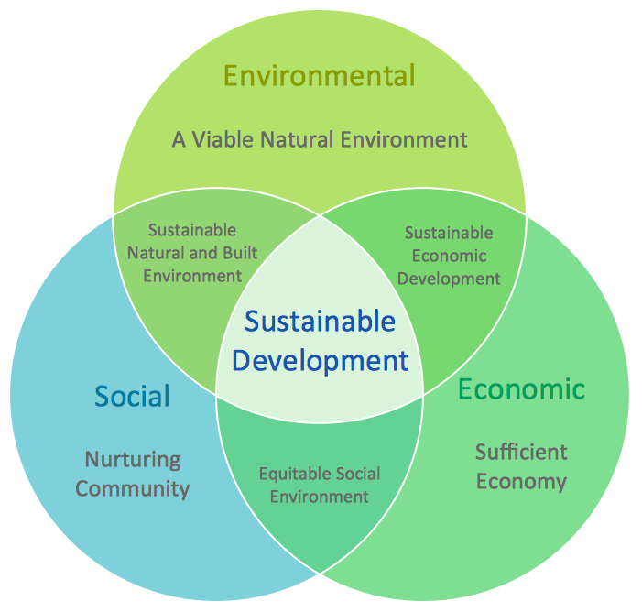

Figure 1 VENN Diagram: Show in the circles where the US and the other countries stand on the pillars of sustainability

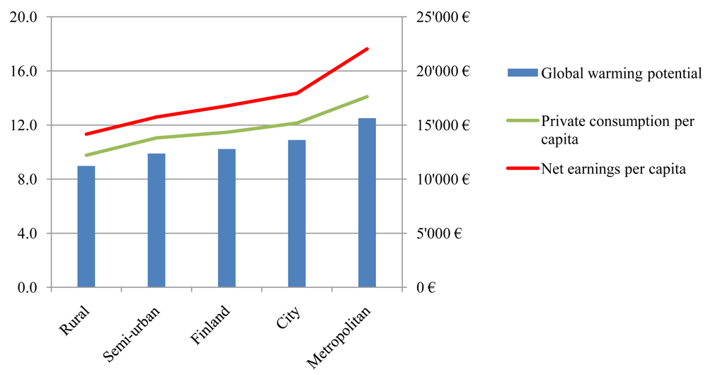

Figure 2 List the US and selected countries along the X-axis with the Y-axis data: You can create this graph in MS EXCEL

* 1. Develop a Power point presentation on your results.

|  |  |  |  |  |  |  |  |  |  |
| --- | --- | --- | --- | --- | --- | --- | --- | --- | --- |
| RUBRIC | | 4  World-Class Learner | 3  Proficient  Learner | 2  Developing Learner | 1  Emergent Learner | | --- | --- | --- | --- | | **Learner at this level has gone beyond mastery of knowledge, skills, & attitudes described in project. World-class learner consistently exhibits high-quality performance.** | **Learner at this level has had opportunities to apply knowledge, skills, & attitudes of component of project. Proficient learner has mastered essential attributes, thus proving mastery.** | **Learner at this level has been exposed to & had opportunity to apply knowledge, skills, & attitudes of project. Developing learner may have only a few essential attributes to master before mastery.** | **Learner at this level may or may not have been exposed to knowledge, skills, & attitudes required by academic standards of the project.** | |
|  | **1= Emergent Learner**  **2 = Developing Learner**  **3 = Proficient Learner**  **4 = World-Class Learner** |