# CHAPTER 2- PLANET, PEOPLE, PROFIT

## ACTIVITY 1: TBL (Triple Bottom Line) vs. S (Sustainability)-TBL

Activity Objective: Describe the three components of Sustainability Triple Bottom Line and provide examples of each component and explain the relationship between planet, people, and profit in the manufacture of a fictitious product that could affect the environment.

Chapter 2 Definition: People, Planet and Profit chapter describes the Triple bottom line (TBL) process within the goals of sustainability, which consists of social equity, economic, and environmental factors. The normal accounting bottom line refers to either the profit or loss that is recorded at the very bottom line of the business balance sheet with expenses on one side and income on the other side. S-TBL (Sustainability Triple Bottom Line) accounting expands the traditional reporting framework to take into account social and environmental performance in addition to the financial performance.

REVIEW TBL VIDEO: <https://www.youtube.com/watch?v=K1ezwDSij6M>

Materials: Chapter 2, paper, computer, printer. Internet Access

### Procedure:

1. Work as partners or small teams
2. Based on the text in chapter 2 and an Internet search, describe in detail the three components of Triple bottom line (TBL) process within the goal of sustainability using a three column format and provide examples of each.
3. Create a VENN diagram showing the results of number 2
4. Define a fictitious product to explain the relationship between planet, people, and profit in this product’s manufacture.
5. Use the text as a guide to explain the relationship for your product
6. Develop an Eco Budget for your product
7. Provide a criticism, you might expect for the S-TBL approach.

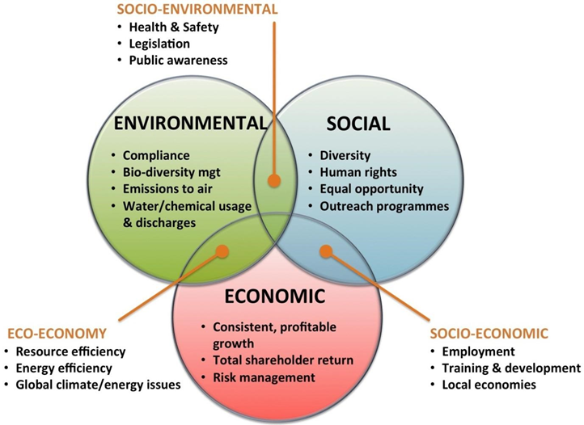

Figure 3 from Chapter 2

|  |  |  |  |  |  |  |  |  |  |
| --- | --- | --- | --- | --- | --- | --- | --- | --- | --- |
| RUBRIC | | 4  World-Class Learner | 3  Proficient  Learner | 2  Developing Learner | 1  Emergent Learner | | --- | --- | --- | --- | | **Learner at this level has gone beyond mastery of knowledge, skills, & attitudes described in project. World-class learner consistently exhibits high-quality performance.** | **Learner at this level has had opportunities to apply knowledge, skills, & attitudes of component of project. Proficient learner has mastered essential attributes, thus proving mastery.** | **Learner at this level has been exposed to & had opportunity to apply knowledge, skills, & attitudes of project. Developing learner may have only a few essential attributes to master before mastery.** | **Learner at this level may or may not have been exposed to knowledge, skills, & attitudes required by academic standards of the project.** | |
|  | **1= Emergent Learner**  **2 = Developing Learner**  **3 = Proficient Learner**  **4 = World-Class Learner** |