## ACTIVITY 4: S-ROI Analysis

Activity Objective: Create an Sustainability-Return on Investment flowchart for the fictitious product you developed in activity 1

Materials: Chapter 2, paper, computer, printer, Internet Access

REVIEW S-ROI VIDEO: <https://www.youtube.com/watch?v=8xxyycLE1oI>

Procedure:

1. Work as partners or small teams
2. Based on the text in chapter 2 explain the Sustainability Return on Investment (S-ROI) process.
3. Based on your review of the text create a flowchart (Figure 8 of chapter 2) or Gantt chart for a Sustainability-Return on Investment for your fictitious product or any product the team chooses.

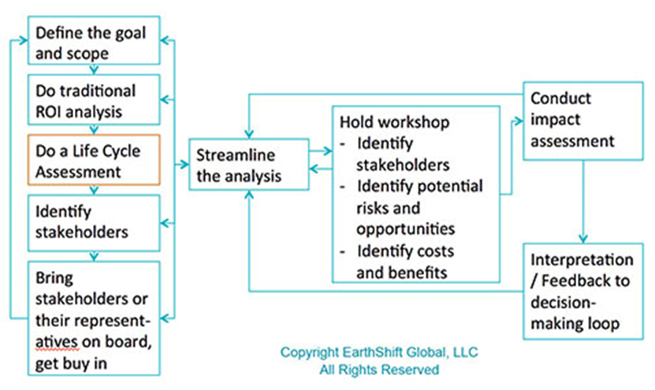

1. Define the project goal, scope, and alternatives, and conduct traditional ROI analysis as a baseline.
2. Do a Life Cycle Assessment (LCA)
3. Identify stakeholders
4. Do a financial analysis for each stakeholder of interest with best case, worst case and most-probable case.
5. Review impact assessment with stakeholders to ensure completeness and agreement
6. Create the flowchart

|  |  |  |  |  |  |  |  |  |  |
| --- | --- | --- | --- | --- | --- | --- | --- | --- | --- |
| RUBRIC | | 4  World-Class Learner | 3  Proficient  Learner | 2  Developing Learner | 1  Emergent Learner | | --- | --- | --- | --- | | **Learner at this level has gone beyond mastery of knowledge, skills, & attitudes described in project. World-class learner consistently exhibits high-quality performance.** | **Learner at this level has had opportunities to apply knowledge, skills, & attitudes of component of project. Proficient learner has mastered essential attributes, thus proving mastery.** | **Learner at this level has been exposed to & had opportunity to apply knowledge, skills, & attitudes of project. Developing learner may have only a few essential attributes to master before mastery.** | **Learner at this level may or may not have been exposed to knowledge, skills, & attitudes required by academic standards of the project.** | |
|  | **1= Emergent Learner**  **2 = Developing Learner**  **3 = Proficient Learner**  **4 = World-Class Learner** |