## ACTIVITY 3: Stakeholders

### Activity Objective: Identify the stakeholders in your fictitious product.

Materials: Chapter 1, paper, computer, printer, Internet Access

### Procedure:

1. Work as partners or small teams
2. Explain what a stakeholder is in a project and why it is important to the success of the project.
3. Create a chart like Figure below to show who your stakeholders are

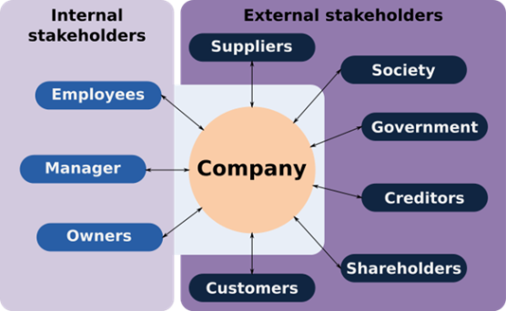

1. Label the stakeholders as Planet, People, or Profit.

|  |  |  |  |  |  |  |  |  |  |
| --- | --- | --- | --- | --- | --- | --- | --- | --- | --- |
| RUBRIC | | 4  World-Class Learner | 3  Proficient  Learner | 2  Developing Learner | 1  Emergent Learner | | --- | --- | --- | --- | | **Learner at this level has gone beyond mastery of knowledge, skills, & attitudes described in project. World-class learner consistently exhibits high-quality performance.** | **Learner at this level has had opportunities to apply knowledge, skills, & attitudes of component of project. Proficient learner has mastered essential attributes, thus proving mastery.** | **Learner at this level has been exposed to & had opportunity to apply knowledge, skills, & attitudes of project. Developing learner may have only a few essential attributes to master before mastery.** | **Learner at this level may or may not have been exposed to knowledge, skills, & attitudes required by academic standards of the project.** | |
|  | **1= Emergent Learner**  **2 = Developing Learner**  **3 = Proficient Learner**  **4 = World-Class Learner** |