**ACTIVITY 4: Carbon Based Emissions**

**Activity Objective:** Define the different types of carbon based automotive exhaust emissions and chronicle what the US automotive industry is doing to reduce those emission and compare this to what other countries are doing.

Materials: Chapter 3, paper, computer, printer, Internet Access

**Procedure:**

1. Work as partners or small teams
2. **REVIEW THESE VIDEOS:**
   1. How to lower car emissions: <https://www.youtube.com/watch?v=43Ev3QJkQ4w>
   2. Clean Air Gas from all Gasoline Cars: <https://www.youtube.com/watch?v=q3LsZttJMUE>
3. Review sections in chapter 3 that deal with the Chemistry of Carbon-Based Emissions.
4. Detail in a research paper the various automotive exhaust emissions currently being regulated by the EPA (Environmental Protection Agency) and list the reason why they are regulated with resultant health consequences.
5. Analyze the difference between the US and selected countries and complete the following tasks:
   1. Write a short comparison essay on the US vs. the selected countries
   2. Select an exhaust emission like Carbon Dioxide or CO2 and list it as the title of your “X” axis. Then list the US and other countries in the “Y” axis in a Histogram to highlight the differences (See below Histogram). You can add any other points to your chart.

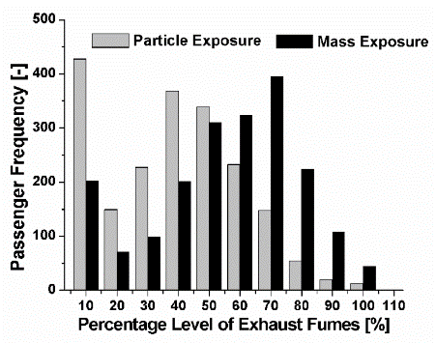

* 1. Develop a Power point presentation on your results

|  |  |  |  |  |  |  |  |  |  |
| --- | --- | --- | --- | --- | --- | --- | --- | --- | --- |
| RUBRIC | | 4  World-Class Learner | 3  Proficient  Learner | 2  Developing Learner | 1  Emergent Learner | | --- | --- | --- | --- | | **Learner at this level has gone beyond mastery of knowledge, skills, & attitudes described in project. World-class learner consistently exhibits high-quality performance.** | **Learner at this level has had opportunities to apply knowledge, skills, & attitudes of component of project. Proficient learner has mastered essential attributes, thus proving mastery.** | **Learner at this level has been exposed to & had opportunity to apply knowledge, skills, & attitudes of project. Developing learner may have only a few essential attributes to master before mastery.** | **Learner at this level may or may not have been exposed to knowledge, skills, & attitudes required by academic standards of the project.** | |
|  | **1= Emergent Learner**  **2 = Developing Learner**  **3 = Proficient Learner**  **4 = World-Class Learner** |