# CHAPTER 4 - REDUCE, REUSE & RECYCLE

## ACTIVITY 1: Making Christmas tree from a Plastic Bottle

Activity Objective: Explain how to fabricate a plastic beverage bottle into a Christmas tree, then construct one, which is an example of reuse, repurpose, and recycling.

BACKGROUND**:** *Reuse* is a term for using an item again after it has been used. This includes conventional reuse where the item is used again for the same function, and creative reuse where it is used for a different function. By taking useful products and exchanging them without reprocessing, reuse help save time, money, energy, and resources. In broader economic terms, reuse offers quality products to people and organizations with limited means, while generating jobs and business activity that contribute to the economy.

Financial motivation was one of the main drivers of reuse, especially in the developing world this driver can lead to very high levels of reuse, however rising wages and consequent consumer demand for the convenience of disposable products has made the reuse of low value items such as packaging uneconomic in richer countries, leading to the demise of many reuse programs. Environmental concerns and regulations, such as the new packaging regulations, are gradually beginning to reverse the situation.

An example of conventional reuse is the selling milk in refillable glass bottles and the use of returnable/reusable plastic boxes, shipping containers, instead of single-use corrugated fiberboard boxes.

*Repurposing* is the process by which an item with one use value is transformed as an object with an alternative use value. It is done using items usually considered to be junk, garbage, or obsolete.

*Recycling* is the breaking down of the used item into raw materials which are used to make new items.

REVIEW VIDEO: 210 Million Tons Rating: <Https://www.youtube.com/watch?v=L1z1cdJZjfQ>

<https://www.youtube.com/watch?v=edXimuzIVhk>

Materials: Chapter 4, paper, computer, printer. Internet Access, Green Colored Plastic Bottle, Scotch tape, and a 12 inch piece of ½ inch PVC plumbing pipe

CREDITS: Christmas tree photos courtesy of <http://www.boredpanda.com/plastic-bottle-recycling-ideas/> stranamasterov.ru

### Procedure:

1. Work as partners or small teams
2. Research how to make items out of old plastic beverage bottles
3. Take the green plastic bottle and cut it into three pieces as shown in Figure 1: the top or neck, the main body, and the bottom.

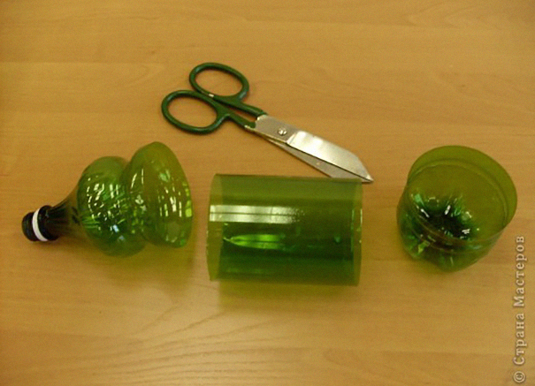

Figure 1 cutting plastic bottle into 3 pieces

1. Cut the bottom and center sections in to 4 or 5 different lengths and using scissors but the plastic like a comb as shown in Figure 2. The base section of the bottle will be used for the bottom tree branches

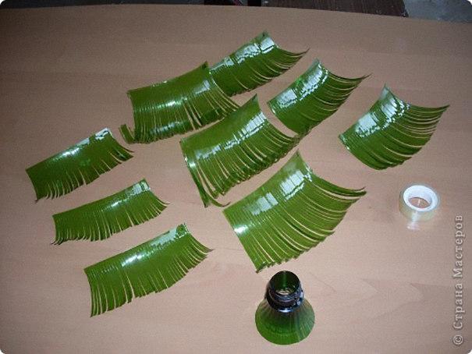

Figure 2

1. Now place the branches around the PVC pipe using scotch tape as shown in Figure 3

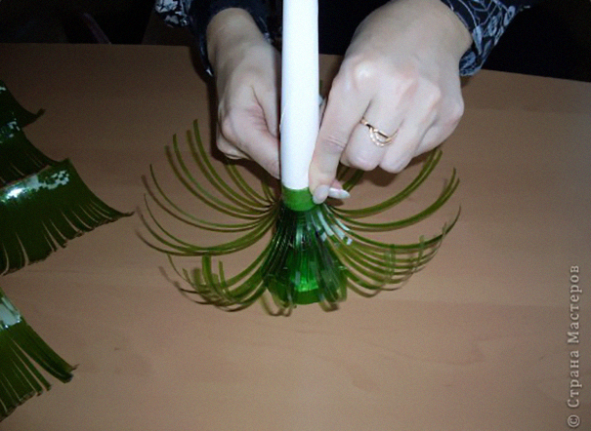

Figure 3 place the PVC pipe in the cut-off top of the plastic bottle and then taping the branches to the PVC pipe

1. Place the PVC pipe in the cut-off top of the plastic bottle and then tape the branches to the PVC pipe, starting at the bottom with base section branches and then going from the longest to the shortest branches.
2. Now you have a completed Christmas tree as shown in Figure 4

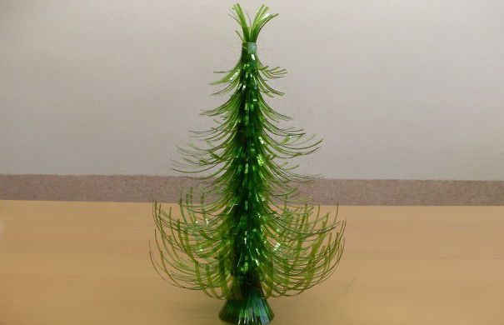

Figure 4 completed Christmas tree

|  |  |  |  |  |  |  |  |  |  |
| --- | --- | --- | --- | --- | --- | --- | --- | --- | --- |
| RUBRIC | | 4  World-Class Learner | 3  Proficient  Learner | 2  Developing Learner | 1  Emergent Learner | | --- | --- | --- | --- | | **Learner at this level has gone beyond mastery of knowledge, skills, & attitudes described in project. World-class learner consistently exhibits high-quality performance.** | **Learner at this level has had opportunities to apply knowledge, skills, & attitudes of component of project. Proficient learner has mastered essential attributes, thus proving mastery.** | **Learner at this level has been exposed to & had opportunity to apply knowledge, skills, & attitudes of project. Developing learner may have only a few essential attributes to master before mastery.** | **Learner at this level may or may not have been exposed to knowledge, skills, & attitudes required by academic standards of the project.** | |
|  | **1= Emergent Learner**  **2 = Developing Learner**  **3 = Proficient Learner**  **4 = World-Class Learner** |