## CHAPTER 5

## ACTIVITY 2: Building an HEV Battery Pack

Activity Objective: Define how the hybrid electric vehicle battery contains such large amount of voltage to operate the electric motors that propel the vehicle.

Definition: Electricity is a natural form of energy that comes from many sources. For example, electricity is in the atmosphere all around us, a generator just puts it in motion. We cannot create or destroy energy, only change it. Yet we can successfully produce electricity and put it into motion. Electric power is the rate at which electrical energy is transferred by an electric circuit. The SI unit of power is the watt, one joule per second. It is usually produced by electric AC (alternating Current) generators (invented by Nikolas Tesla), but can also be supplied by other sources: such as batteries or solar cells.

REVIEW VIDEO: Electrical power simplified <https://www.youtube.com/watch?v=aCOph1lpYc8>

HEV (Hybrid Electric Vehicles) use an internal combustion engine to turn a generator, which either charges batteries. The engine operates to keep the batteries charged and in some applications also powers the HEV. In some electric vehicles, like the Chevrolet Volt, the engine only operates to keep the batteries charged. Most current production HEVs use nickel-metal hydride (NiMH) battery technology for the high-voltage battery. The NiMH battery is recyclable (Chevrolet Volt uses Lithium-Ion batteries like a cell phone). Nickel-metal hydride (NiMH) uses a positive electrode made of nickel hydroxide and potassium hydroxide electrolyte. The nominal voltage of a NiMH battery cell is 1.2 volts similar to a 1.5 volt flashlight alkaline battery.

In this activity, you will be using 9 volt alkaline batteries. A typical nine-volt battery contains six 1.5 volt AAAA batteries connected in series (**Figure 1**). Theses batteries are connected in series and would add up to 9 volts (1.5 X 6= 9 Volts). You would have to know a little about series circuit to completely understand this concept. Basically in a series circuit voltage is accumulative. The batteries when connected in series positive to negative will add up together.

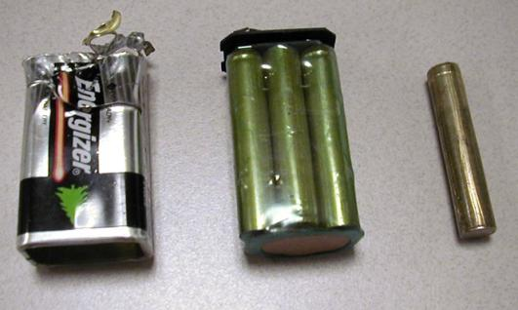

Figure 1 Nine volt battery

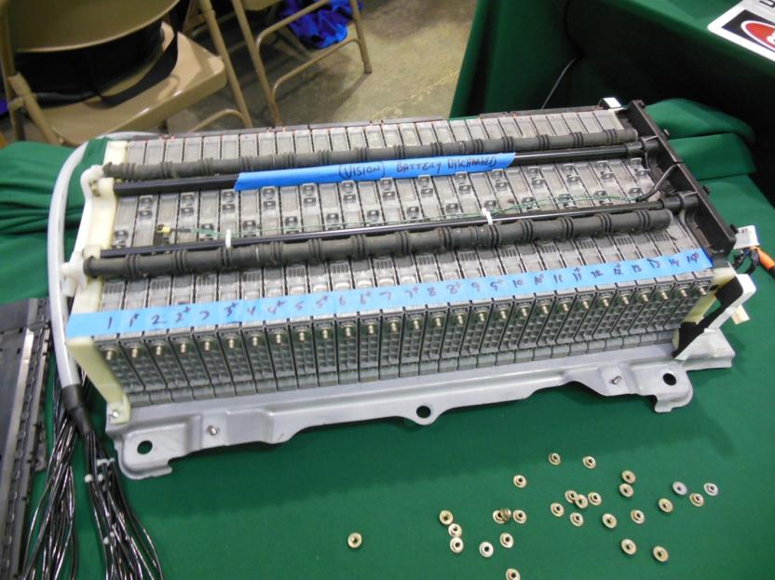

Figure 2 HEV NiMH battery used in a Toyota Prius

HEV battery cells are connected in series and each cell of a NiMH battery produces only 1.2 volts (**Figure 2**). To build a battery pack that is capable of producing high voltage, a lot of individual NiMH cells must be connected in series. Each NiMH cell is capable of producing only 1.2 volts. A high-voltage battery is built using multiples of 1.2 volts. To build a 144-volt battery, 114 individual NiMH cells must be connected together in series (144 × 1.2 volts). Obviously, the higher the voltage output of the battery, the greater the number of individual battery cells that must be used to achieve the necessary voltage

Use a Digital Multimeter (DMM) to measure voltage across the positive and negative posts and then connect a series a 9 volt batteries together to add up to a pretend HEV battery pack.

### Materials

3 Nine (9) volt batteries

1 package of jumper leads RADIOSHACK #2781157 $7.49

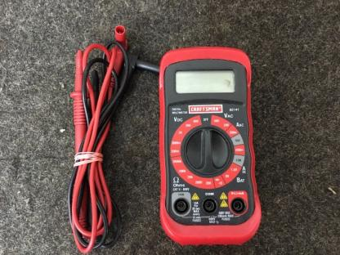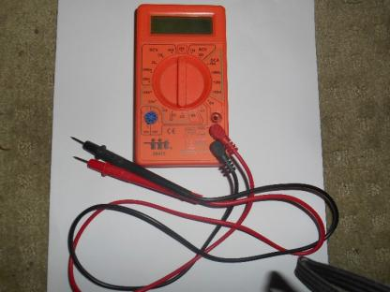

Craftsman DMM (Digital Multimeter) available on [www.ebay.com](http://www.ebay.com) for about $10.00

Procedure:

1. First connect the red and black probes to the DMM and connect a RED jumper cable to the RED DMM lead and a black jumper cable to the black DMM lead and set the dial on DCV (DV volts) 20. Then connect the RED jumper alligator clip to the positive post of the 9-volt battery and the black jumper alligator clip to the negative battery post as shown in **Figure 3** to read 9.17 volts on this 9-volt battery.

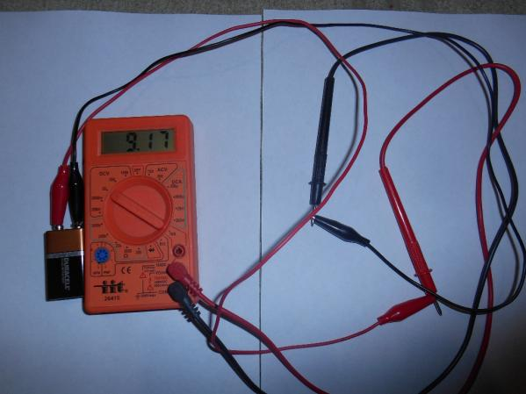

Figure 3 showing measuring battery voltage on one 9-volt battery

1. The first 9-volt battery reads 9.17 volts.

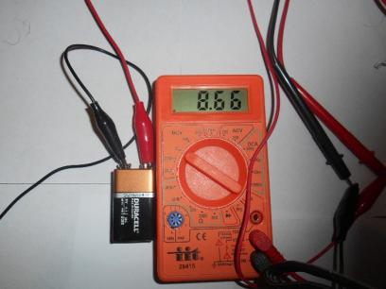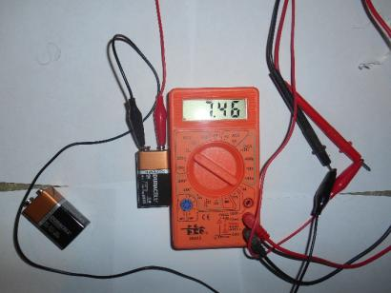

Figure 4 voltage readings on the other two 9-volt batteries

1. Using the same procedure check the other two 9-volt batteries. The next one in this case read 8.66 volts and last one read 7.46 volts as shown in **Figure 4**.
2. Add the voltage readings you obtained on your three batteries and what did you get___________________________________. In sample activity, the total was 25.29 volts for all three batteries.

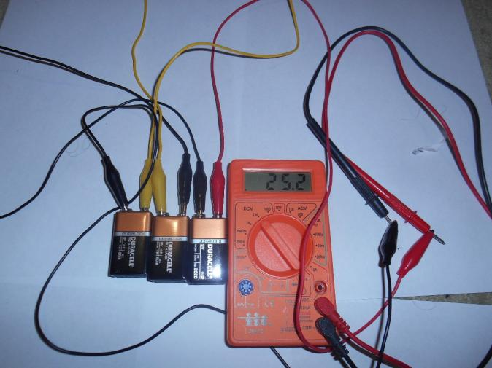

Figure 5 All three 9-volt batteries connected in series and connected to the DMM

1. Now connect all three 9-volt batteries in series and read the voltage on the DMM. Set the DMM dial to DCV 200 because we will be measuring more than 20 volts DC. Using jumper wires connect all three 9-volt batteries in series by stringing the batteries together positive to negative as shown in **Figure 5**.
2. In our sample we measured 25.2 volts on the DMM, which is very close to the mathematical calculation. *Digital multimeters average their readings*. Why?

|  |  |  |  |  |  |  |  |  |  |
| --- | --- | --- | --- | --- | --- | --- | --- | --- | --- |
| RUBRIC | | **4**  **World-Class Learner** | **3**  **Proficient  Learner** | **2**  **Developing Learner** | **1**  **Emergent Learner** | | --- | --- | --- | --- | | **Learner at this level has gone beyond mastery of knowledge, skills, & attitudes described in project. World-class learner consistently exhibits high-quality performance.** | **Learner at this level has had opportunities to apply knowledge, skills, & attitudes of component of project. Proficient learner has mastered essential attributes, thus proving mastery.** | **Learner at this level has been exposed to & had opportunity to apply knowledge, skills, & attitudes of project. Developing learner may have only a few essential attributes to master before mastery.** | **Learner at this level may or may not have been exposed to knowledge, skills, & attitudes required by academic standards of the project.** | |
|  | **1= Emergent Learner**  **2 = Developing Learner**  **3 = Proficient Learner**  **4 = World-Class Learner** |