## CHAPTER 5

## ACTIVITY 3: Kinetic Energy Observed Using Ramps

## Activity Objective: Determine the kinetic energy of a toy vehicle going down a ramp

Materials: Chapter 5, paper, computer, printer, Internet Access, ramp, 3 toy vehicles of three different sizes: small, medium, and large; and materials to build a ramp.

Background: Kinetic energy is the energy of motion. If an object is moving, it has kinetic energy. When you discuss kinetic energy, you must also think about potential energy. Potential Energy is the capacity to perform work, or energy at rest. If a car or truck is sitting at the top of a ramp, it has a certain amount of energy because of its position at rest or potential energy. If you release the car go, it will go down the ramp. The gravitational potential energy of the car sitting at the top of the ramp is converted into kinetic energy once the car begins to move.

Procedure:

1. You can work as an individual, in pairs or as a team on this activity
2. First build a ramp, usually a large flat long board will do, see **Figure 6**. You can make the ramp out of whatever materials you have – train tracks, a cardboard tube, a box, a board, a piece of cardboard, or any flat surface that you can incline. In the example, I a ramp at my business.

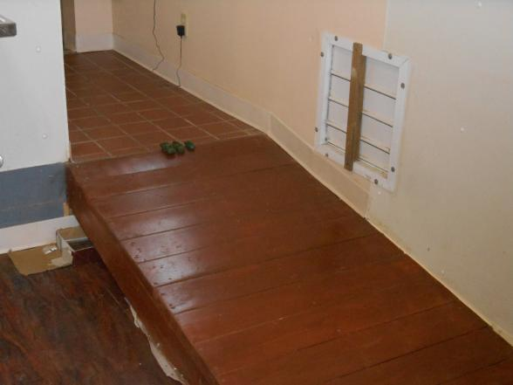

Figure 6 ramp

1. I used three different sized vehicles for the sample. In your activity, use a small, medium, and large vehicle.
2. Start each car at the top of the ramp and time how long they take to reach the bottom. Team members can predict which vehicle will reach the bottom first. Observe what happens. Which one reached the bottom first? Why?
3. If the masses (weights) are equal, the car with the greatest velocity (range of change of position) would have the highest kinetic energy. If the velocities are equal, the car with the greatest mass would have the highest kinetic energy. If neither the velocities nor the masses are equal, you would need to calculate the kinetic energy (**Kinetic energy = ½ mv2** or ½ mass x velocity squared). To make these calculations you will have to measure your ramp in feet, so the velocity can be measured in feet per second. You can use a stop watch to measure how many seconds it takes to go down the ramp and the feet traveled. The weight of the vehicles is needed to calculate Kinetic Energy.
4. Answer the following questions:
   1. Which vehicle had the highest Kinetic Energy? ________________
   2. Which vehicle was the heaviest? ________________________
   3. Which vehicle finished first? ____________________________
5. Things you can change to alter the results of your activity
   1. Change height of ramp.
   2. Change shape of vehicles going down the ramp
   3. Change size of vehicles but keep weight the same.
   4. Change weight of vehicles but keep their size the same like using a truck with weight in it
   5. Change surface of ramp to rough or more smooth

What were the results of the changes made to then vehicles use or the surface of the ramp?

|  |  |  |  |  |  |  |  |  |  |
| --- | --- | --- | --- | --- | --- | --- | --- | --- | --- |
| RUBRIC | | **4**  **World-Class Learner** | **3**  **Proficient  Learner** | **2**  **Developing Learner** | **1**  **Emergent Learner** | | --- | --- | --- | --- | | **Learner at this level has gone beyond mastery of knowledge, skills, & attitudes described in project. World-class learner consistently exhibits high-quality performance.** | **Learner at this level has had opportunities to apply knowledge, skills, & attitudes of component of project. Proficient learner has mastered essential attributes, thus proving mastery.** | **Learner at this level has been exposed to & had opportunity to apply knowledge, skills, & attitudes of project. Developing learner may have only a few essential attributes to master before mastery.** | **Learner at this level may or may not have been exposed to knowledge, skills, & attitudes required by academic standards of the project.** | |
|  | **1= Emergent Learner**  **2 = Developing Learner**  **3 = Proficient Learner**  **4 = World-Class Learner** |