## ACTIVITY 3: Converting a Gasoline Fueled Vehicle to Propane

## **Activity** **Objective**: Write a detailed plan on how to convert a vehicle fueled by gasoline to propane or LPG (Liquid Petroleum Gas)

Materials: Chapter 1, paper, computer, printer, Internet Access

Definition: Propane is the most widely used of all the alternative fuels mainly because of its use in fleets, which utilize a central refueling station. Propane is normally a gas but is easily compressed into a liquid and stored in inexpensive containers. When sold as a fuel, it is also known as liquefied petroleum gas (LPG) or LP gas, because the propane is often mixed with about 10% of other gases, including: " Butane " Propylene " Butylene " Mercaptan, to give the colorless and odorless propane a smell Propane is nontoxic, but if inhaled can cause asphyxiation through lack of oxygen. Propane is heavier than air and lays near the floor if released into the atmosphere. Propane is commonly used in forklifts and other equipment located inside warehouses and factories, because the exhaust from the engine using propane is not harmful. Propane is a by-product of petroleum refining of natural gas. In order to liquefy the fuel, it is stored in strong tanks at about 300 PSI (2,000 kPa). The heating value of propane is less than that of gasoline; therefore, more is required, which reduces the fuel economy.

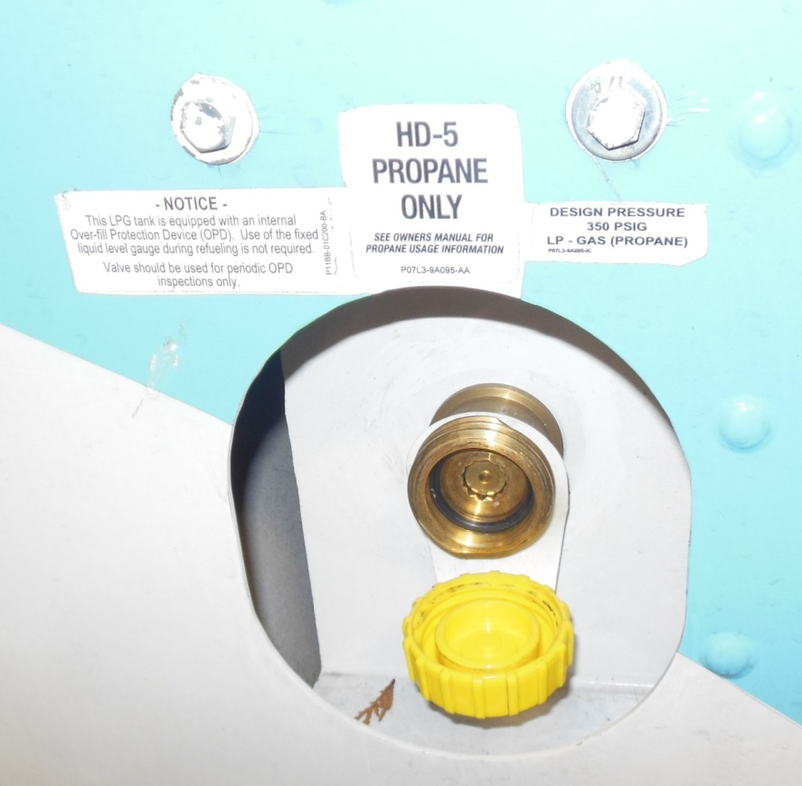

REVIEW VIDEO: [www.sus101.com](http://www.sus101.com) <https://youtu.be/H4Q2-whIP5c>

Procedure:

1. Work as partners or small teams
2. Review the above video and the other material on [www.sus101.com](http://www.sus101.com)
3. Research the propane conversion process from gasoline fueled to propane fueled vehicles
4. Take or locate photographs of propane conversion to add to your report
5. Write a detailed plan on how to convert a gasoline fueled vehicle to propane
6. In your report detail if this conversion will lower the vehicles exhaust emissions and why

|  |  |  |  |  |  |  |  |  |  |
| --- | --- | --- | --- | --- | --- | --- | --- | --- | --- |
| RUBRIC | | **4**  **World-Class Learner** | **3**  **Proficient  Learner** | **2**  **Developing Learner** | **1**  **Emergent Learner** | | --- | --- | --- | --- | | **Learner at this level has gone beyond mastery of knowledge, skills, & attitudes described in project. World-class learner consistently exhibits high-quality performance.** | **Learner at this level has had opportunities to apply knowledge, skills, & attitudes of component of project. Proficient learner has mastered essential attributes, thus proving mastery.** | **Learner at this level has been exposed to & had opportunity to apply knowledge, skills, & attitudes of project. Developing learner may have only a few essential attributes to master before mastery.** | **Learner at this level may or may not have been exposed to knowledge, skills, & attitudes required by academic standards of the project.** | |
|  | **1= Emergent Learner**  **2 = Developing Learner**  **3 = Proficient Learner**  **4 = World-Class Learner** |