# CHAPTER 8

# SOLAR ELECTRIC GENERATION

## ACTIVITY 1: Cost Benefits PV (Photovoltaics) System vs. CSP (Concentrating Solar Power) System

Activity Objective: Create a graph in MS Excel showing the costs benefits of a PV or photovoltaic system compared to a CSP or Concentrating Solar Power showing costs vs. energy savings and determine which is more cost effective based on the data.

Definition: Photovoltaics or PV is the production of electric current at the interface of two semiconductor materials, which causes them to absorb photons of light and release electrons to produce electricity. PV concerns the conversion of light into electricity using semiconducting materials (Solar Panels) that exhibit the photovoltaic effect as electrical current being produced at the junction of light and a semiconductor or the use of solar (sun based) energy. It is this photoelectric effect that puts electricity in motion using light and solid state devices. Photovoltaics mean the direct conversion of light into electricity at the atomic level. Certain materials exhibit a property known as the photoelectric effect that causes them to absorb photons of light and release electrons. When these free electrons are captured, an electric current results that can be used as electricity.

The Concentrating Solar Power (CSP) technology uses three different approaches to solar energy: power tower systems, trough systems, and dish/engine systems. CSP uses focused sunlight and generates electric power using mirrors to concentrate (focus) the sun's energy and convert it into heat to power a steam generator or Sterling engine. A CSP installation has two parts: one part that collects solar energy and another part that converts the heat energy to electricity. The solar power tower shown uses an array of dual-axis tracking reflectors (heliostats/Fresnel reflectors) that concentrate sunlight on a central receiver on top of the tower. The receiver uses sea water as a working fluid that is heated to 932–1,832 ° F and stored in steam drum as a heat source for a power generator turbine.

An advantage of the solar power tower is the reflectors can be adjusted. Power-tower development is less advanced than trough system (covered later in this chapter), but it offers higher efficiency and better energy storage capability. The DOE (Department of Energy) Solar Energy Technologies offers video on their web site showing how concentrating solar power works (with a parabolic trough system). Fresnel reflectors are flat mirror strips that concentrate sunlight onto tubes through which working fluid sea water is pumped. Flat mirrors allow more reflective surface to capture more of the available sunlight, and cheaper than parabolic reflectors.

**REVIEW VIDEOS:**

Photovoltaics Rating: <https://www.youtube.com/watch?v=4Cam0uREgPI>

Difference in cost vs benefits of a PV system to CSP system, Residential solar PV economics <https://www.youtube.com/watch?v=fd_xf_INnNI>

Materials: Chapter 8, paper, computer, printer. Internet Access, MS EXCEL or other graph software, graph paper

### Procedure:

1. Work as partners or small teams.
2. Research and brainstorm photovoltaic costs and energy savings and Concentrating Solar Power (CSP) costs and energy savings.
3. Based on the text in chapter 8 and the Internet search, create a graph showing the difference between PV and CSP with regards to energy savings vs. cost.
4. In your final analysis provide a recommendation on which is more cost-effective.

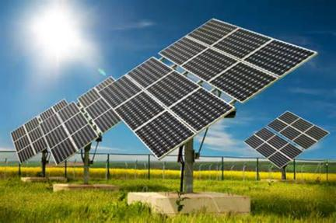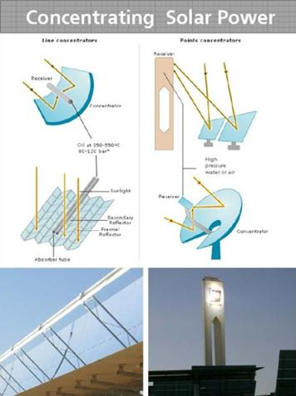

Figure 1 PV and CSP systems

|  |  |  |  |  |  |  |  |  |  |
| --- | --- | --- | --- | --- | --- | --- | --- | --- | --- |
| RUBRIC | | **4**  **World-Class Learner** | **3**  **Proficient  Learner** | **2**  **Developing Learner** | **1**  **Emergent Learner** | | --- | --- | --- | --- | | **Learner at this level has gone beyond mastery of knowledge, skills, & attitudes described in project. World-class learner consistently exhibits high-quality performance.** | **Learner at this level has had opportunities to apply knowledge, skills, & attitudes of component of project. Proficient learner has mastered essential attributes, thus proving mastery.** | **Learner at this level has been exposed to & had opportunity to apply knowledge, skills, & attitudes of project. Developing learner may have only a few essential attributes to master before mastery.** | **Learner at this level may or may not have been exposed to knowledge, skills, & attitudes required by academic standards of the project.** | |
|  | **1= Emergent Learner**  **2 = Developing Learner**  **3 = Proficient Learner**  **4 = World-Class Learner** |